Generally, to get a web site to work on your machine you need to turn it to work as a web server.
For our PHP web sites, you need to install Apache server, PHP and MySQL.
Xampp is a magic tool that installs Apache server, PHP and MySQL for you.

Web server Installation

- Download Xampp tool from here, or here.
- Install it just with its default options.
Here are some screen-shots from installation:
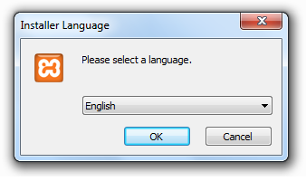
Figure 1.1
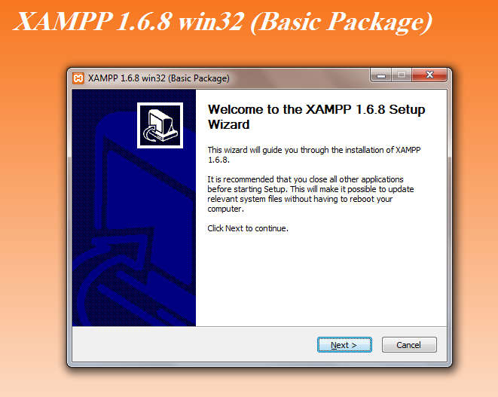 Figure 1.2
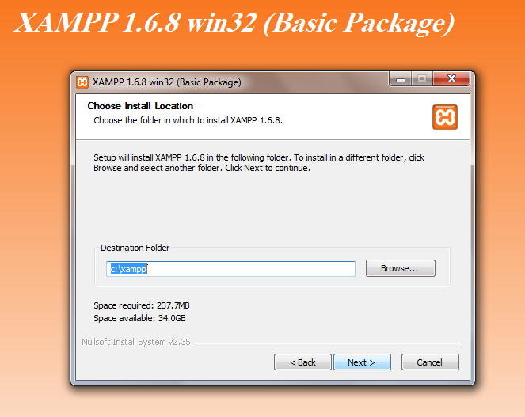 Figure 1.3
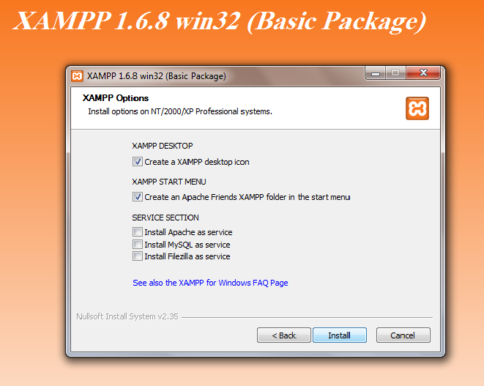Figure 1.4
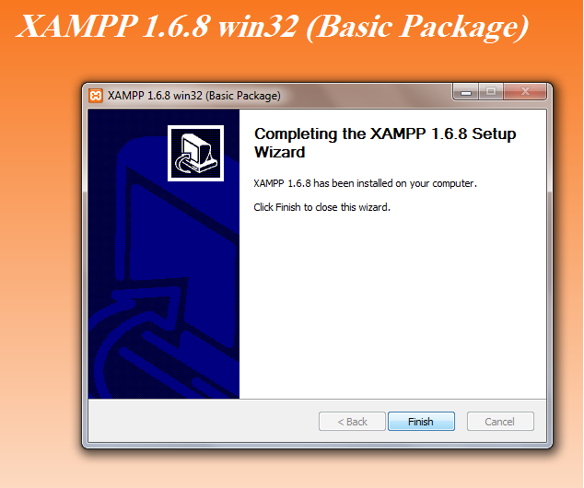Figure 1.5

Start web server

- Xampp control is starting immediately after installation. You will find it in notifications area:
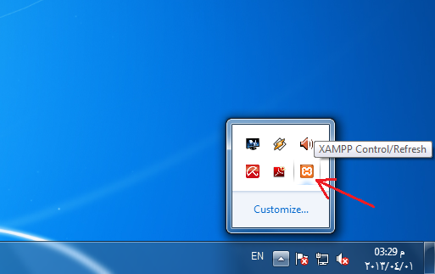
Figure 2.1
If you didn't find it, go to c:\xampp and start xampp-control.exe .
- Open the Xampp control and press start button of Apache and MySql.
if a green label displayed beside the buttons this means that Apache and MySql were started successfully.
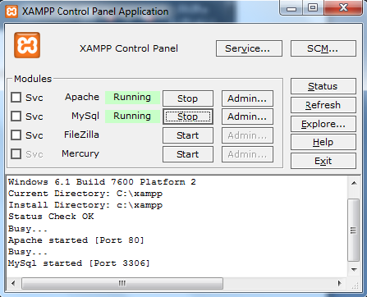
Figure 2.2
Troubleshooting:

If apache doesn't start and give an error message said that "port 80 is busy”, usually shown in, so, there is another application uses port 80, usually it is microsoft IIS.
there is a tool came with xampp, called xampp-portcheck.exe, my help you to know the application that uses port 80.

To change the port that apache is listening to, open the apache config file:
(XAMPPROOT)\apache\conf\httpd.conf
and find the following line and change the port to any free port number:

Listen 80

Here is an overview of Xampp tools:
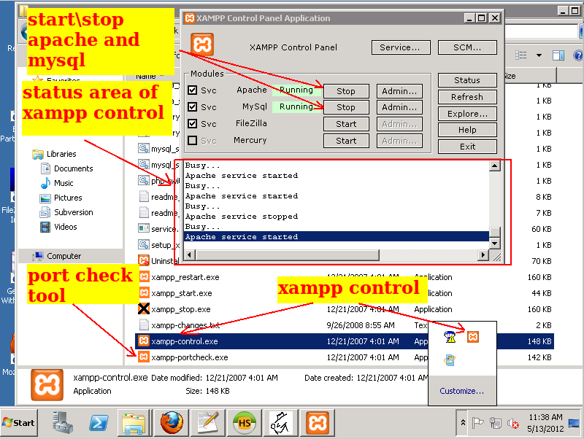
Figure 2.3

- Now open the following URL on your web browser:
http://localhost
this is the homepage for your local web server.

you will see the following page:

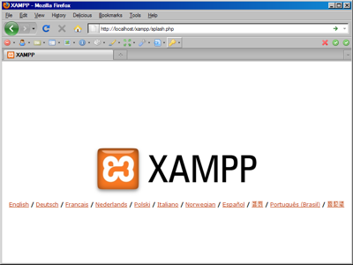
figure 2.4

click on english, you will see the following page:

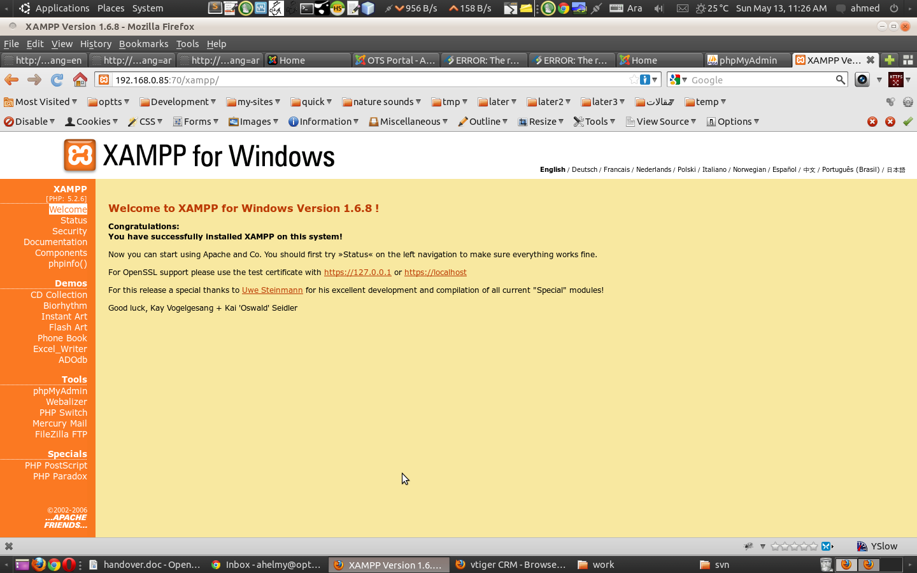
Figure 2.5

Now you are ready to setup the PHP site.

Web site Installation

The web site installation is divided into two parts: Database installation, and the PHP web site installation.

Database installation
1- open any MySQL client, e.g., HeidiSQL and SQLYog.
Xampp comes with a web-based mydsql client called PhpMyAdmin.
Put this URL in web browser:
http://localhost/phpmyadmin

2- create a new database and name it: kims_online.
3- import the database dump file.

Web site installation
1- Go to the root directory of apache. it is usually:
c:\xampp\htdocs
2- Create a new directory, name it: kims
3- extract site zipped file inside the new directory.
4- open the file: c:\xampp\htdocs\kims\app\config\parameters.yml with any text editor and change database_user and database_password to your mysql right username and password.
Usually the default mysql username is: root, and password is blank, so put this character: ~ which symbolizes to blank.

Now, the site is ready.
Open it via the URL:
http://localhost/kims/web/

